**Topic 2: Machine Learning: Introduction to Algorithms**

* + 1. **An Introduction to Statistical Learning with applications in R rental**

NO questions will be drawn from this section about R.

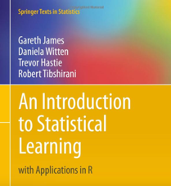  **R**

* + 1. **Statistical Learning.** Hastie rental.

1. **Explain why we estimate a function with data, including the role of input and output variables, and their synonyms, as well as error terms (reducible and irreducible), expected values and variance.**

The essence of machine learning is function estimation.

Irreducible error or inherent uncertainty is associated with a natural variability in a system. Reducible Error can be and should be minimized further to maximize accuracy.

Reducible error can be further decomposed into “error due to squared BIAS” and “error due to VARIANCE.”

Portfolio systematic error is irreducible. Reducible error can be diversified away.

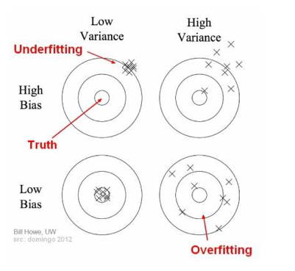

1. **Compare and contrast parametric VS. nonparametric learning methods.**

Parametric makes ASSUMPTIONS about the parameters.

1. **Describe the tradeoffs between predication accuracy, flexibility and model interpretability, including the role of over fitting**

Prediction Accuracy:

Prediction accuracy is expressed as the correlation between the prediction and the actual score. Accuracy of 1 indicates a perfect accuracy, whereas the accuracy of 0 indicates a random guess.

Flexibility:

It is a measure of how much a fitted model can vary with a given training dataset. How well it performs with NEW data. The more the flexible the model is, the better it can fit the train data. Known as the generalization performance.

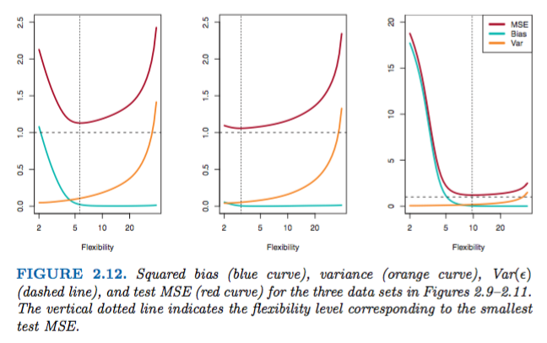

Model Interpretability:

Interpret means to explain or to present in understandable terms. In the context of ML systems, interpretability is the ability to explain or to present in understandable terms to a human.

Overfitting:

In statistics, overfitting is "the production of an analysis that corresponds too closely or exactly to a particular set of data and may therefore fail to fit additional data or predict future observations reliably.”An overfitted model is a statistical model that contains more parameters than can be justified by the data.

1. **Determine when a supervised model is preferable to unsupervised or semi-supervised learning models.**

Supervised: You have a target variable. Expensive data to acquire.

Unsupervised: You don’t have a target variable. Cheap data to acquire.

Supervised: Labelled. Regression. Decision tree. Random forest.

Unsupervised: Unlabeled. Mostly clustering algorithms.

Semi-supervised: Take unlabeled data and send through the trained model to give it a label. This is called pseudo-labeling.

 Note: Leila Janah. Training data. Sama.

1. **Explain how the appropriateness of regression problems relative to classification problems may be related to whether responses are quantitative VS. qualitative**

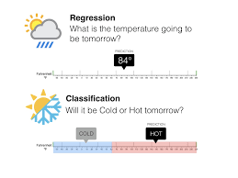

* Regression is about predicting a quantity
* Classification is about predicting a label
  + 1. **Assessing Model Accuracy**

1. **Recognize and explain the recognition of mean squared error. MSE.**

The MSE is a measure of the quality of an estimator—it is always non-negative, and values closer to ZERO are better.

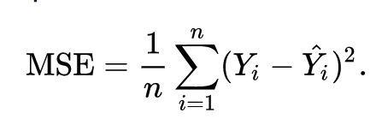 It’s the squared residuals / the number of items

Mean squares represent an estimate of **population** variance. It is calculated by dividing the corresponding sum of squares by the degrees of freedom.

1. **Explain the goal of measuring quality of fit by minimizing training & test mean square errors (MSEs) and the implications of different levels of flexibility (degrees of freedom) for training and test MSEs.**

* It is important to realize that this MSE value is computed using only the *training* data. That is, it is computed using only the data that the model was fitted on. Hence, it is actually known as the **training MSE**.
* The MSE is a measure of the quality of an estimator—it is always non-negative, and values closer to zero are better.
* The closer to 0 the better for MSE.
* Degrees of freedom give flexibility
* Our goal is to select the model where the *test MSE* is lowest across choice of other models.
* Unfortunately, it is difficult to calculate the test MSE. This is because we are often in a situation where we *do not have any test data available*.
* Why can we not simply use the model with the lowest *training* MSE?". The simple answer is that we are unable to use this approach because there is no guarantee that the model with the lowest *training* MSE will also be the model with the lowest *test* MSE. Why is this so? The answer lies in a particular property of statistical machine learning methods known as the **bias-variance tradeoff**.

1. **Explain the purpose of cross-validation**

VALIDATE your model.

Cross Validation is used to assess the predictive performance of the models and to judge how they perform outside the sample to a New Data set also known as Test data.

The motivation to use cross validation techniques is that when we fit a model, we are fitting it to a training dataset.

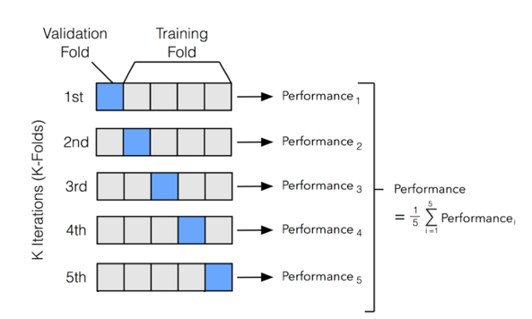

1. **Explain the bias-variance trade-off with an MSE decomposition into 3 fundamental quantities.**

The expected TEST MSE can be decomposed into three fundamental quantities.



1. Variance
2. Squared Bias
3. The variance of the error terms

As we use more flexible methods, the variance will increase, and the bias will decrease.

BIAS

The *bias error* is an error from erroneous assumptions in the learning algorithm. High bias can cause an algorithm to miss the relevant relations between features and target outputs (underfitting).

VARIANCE

The *variance*is an error from sensitivity to small fluctuations or noise in the training set. High variance can cause an algorithm to model the random noise in the training data, rather than the intended outputs (overfitting). Too much noise.

MSE

The average squared difference between the estimated values and the actual value

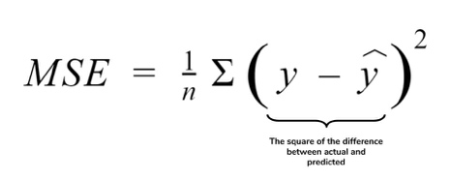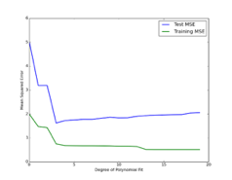

1. **Explain the salient features of a Simple Bayes classifier (for two classes) including the Bayes decision boundary and Bayes error rate.**

﻿Thus far, our discussion of model accuracy has been focused on the regression setting.

But many of the concepts that we have encountered, such as the bias-variance trade-off, transfer over to the classification setting with only some modifications due to the fact that yi is no longer numerical.

﻿There is a very simple classifier we can use that assigns each observation to the most likely class, given its predictor values. ﻿This very simple classifier is called the Bayes classifier.

Bayes is quick and dirty. Generative. Iterate to make improvements. Good for large data sets. Logistic or regression is discriminative.

Bayes Classifier

﻿Pr (Y = j|X = x0)

Note that above equation is a conditional probability: it is the probability Y = j, given the observed predictor vector x0.

Bayes decision boundary:

﻿The purple dashed line represents the Bayes decision boundary.

The orange background grid indicates the region in which a test observation will be assigned to the orange class, and the blue background grid indicates the region in which a test observation will be assigned to the blue class.

Bayes error rate = Irreducible error:

In [statistical classification](https://en.wikipedia.org/wiki/Statistical_classification), Bayes error rate is the lowest possible error rate for any classifier of a random outcome (into, for example, one of two categories) and is analogous to the irreducible error.

1. **Explain how the K-nearest neighbors (KNN) classifier is related to the Bayes classifier and how the choice of K impacts the results.**

﻿In theory we would always like to predict qualitative responses using the Bayes classifier. But for real data, we do not know the conditional distribution of Y given X, and so computing the Bayes classifier is impossible. Computing the Bayes classifier is impossible without the conditional probabilities.

Therefore, the Bayes classifier serves as an unattainable gold standard against which to compare other methods.

Many approaches attempt to estimate the conditional distribution of Y given X, and then classify a given observation to the class with highest estimated probability.

One such method is the K-nearest neighbors (KNN) classifier.

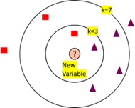

﻿KNN can often produce classifiers that are surprisingly close to the optimal Bayes classifier.

KNN applies Bayes rule and classifies the test observation x0 to the class with the largest probability.

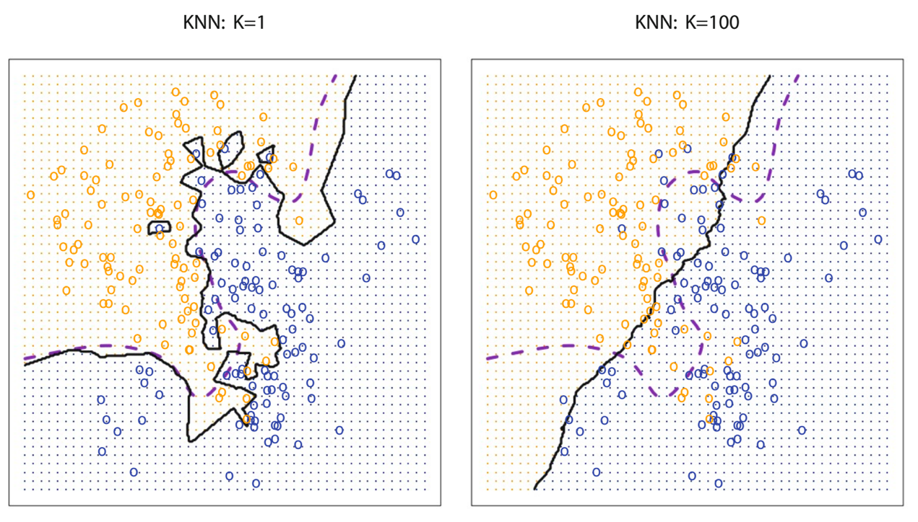

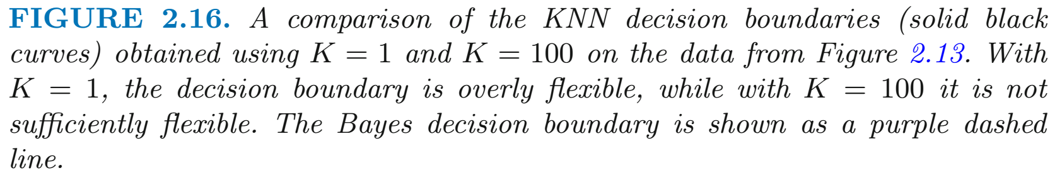

﻿

Opposites: A low K will give high variance. Overfit.

 Note: Cat is her neighbor for K-NN.

* + 1. **Motivation for using neural nets to recognize handwritten digits.** Site article.

 Note: Michael Nielsen

1. **Describe the use of a training set as an alternative to a rules-based program to recognize digits.**

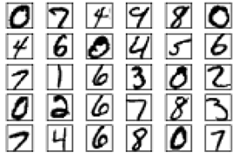

The neural network uses the examples to automatically infer rules for recognizing handwritten digits. Furthermore, by increasing the number of training examples, the network can learn more about handwriting, and so improve its accuracy.

We can build a better handwriting recognizer by using thousands or even millions or billions of training examples.

* + 1. **Perceptron neurons.**

1. **Calculate the output of a perceptron neuron**

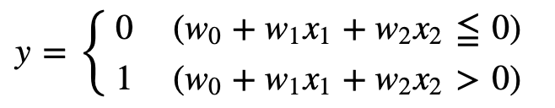

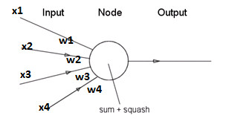

1. **Describe the intuition of a perceptron as a decision-making device.**

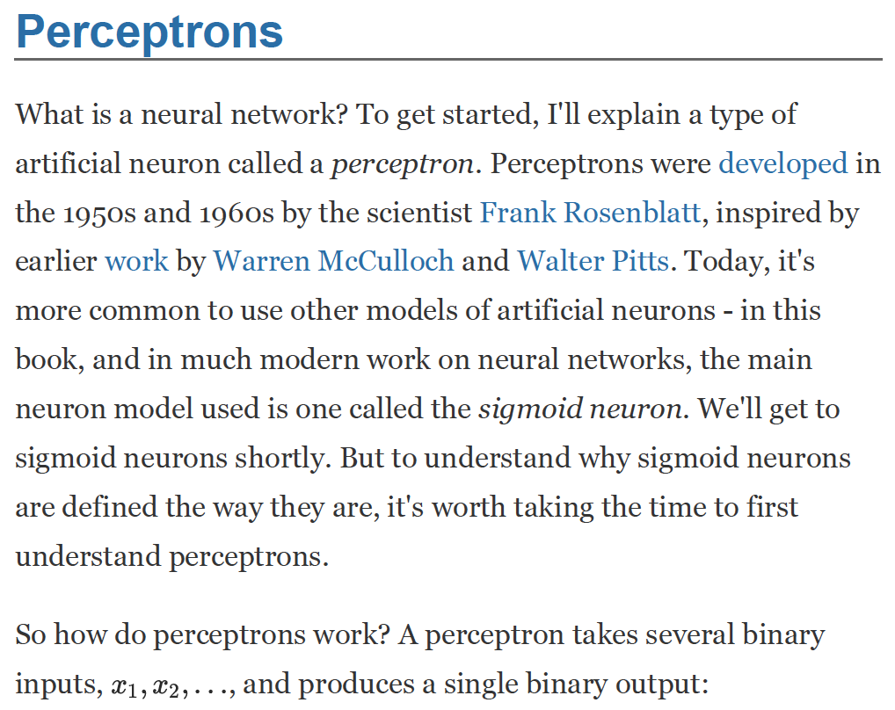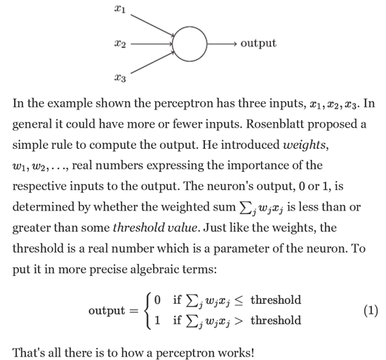

A human neuron comparison.

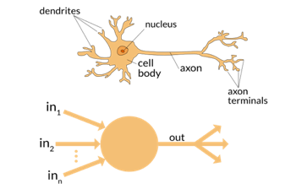

1. **Describe a perceptron as a NAND gate and what it implies for perceptron networks with respect to computing logical functions.**

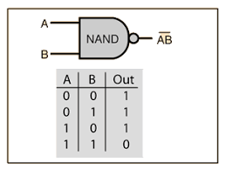

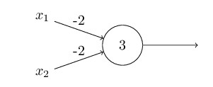

An input of 1,1 gives zero for the NAND gate.

The BIAS is 3. The Bias is an easier way of including the threshold in your perceptron. You can think of a bias of how easy it is to get the perceptron to output a 1 or to get it to fire.

But the input 1,1 produces output 0, since (−2) ∗1+(−2) ∗1+3=−1 is negative. And so, our perceptron implements a NAND gate.

It is considered as a "universal" gate in Boolean algebra as it is capable of producing all other logic gates.

1. **Explain how perceptron neurons are more than new types of NAND gates.**

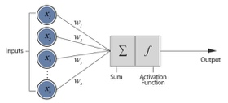Tune the weights and biases.

We can devise learning algorithms which can automatically tune the weights and biases of a network of artificial neurons.

This tuning happens in response to external stimuli, without direct intervention by a programmer.

These learning algorithms enable us to use artificial neurons in a way which is radically different to conventional logic gates.

Instead of laying out a network of NAND and other gates, our network can simply learn to solve problems. Sometimes difficult problems which a conventional circuit could never do.

* + 1. **Sigmoid neurons**

1. **Recognize a limitation of perceptron neurons that can be overcome with sigmoid neurons**

Remember, the sigmoid function is used to squish the weights between 0 and 1.

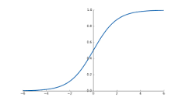

Introducing sigmoid neurons where the output function is much smoother than the step function seems like a logical and obvious thing to do.

A sigmoid function is a mathematical function with a characteristic “S”-shaped curve, also called the **sigmoid** curve.

1. **Recognize and differentiate perceptron neurons from sigmoid neurons**

Discreet binary output between 0 and 1 VS. continuous output between 0 and 1.

Sigmoid neuron is similar to perceptron but modified so that small change result only a small change in their output. Gives you the smoothness.

1. **Calculate the output of a sigmoid function which is also referred to as a logistic function.**
2. ]
3. ]

Sigmoid function = Logistic function

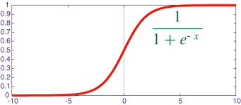

1. **Explain why the smoothness of the Sigmoid function is important**

Many NATURAL processes, such as those of complex system learning curves, exhibit a progression from small beginnings that accelerates and approaches a climax over time.

When a specific mathematical model is lacking, a sigmoid function is often used.

Sigmoid functions are often used in artificial neural networks to introduce nonlinearity in the model.

* + 1. **The architecture of neural networks**

1. **Identify the components of a neural network with appropriate terminology**

* Input Layer
* Hidden (computation) Layers
* Output Layer

1. **Describe the central feature of a feed forward network**

In this network, the information moves in only one direction, forward, from the input nodes, through the hidden nodes (if any) and to the output nodes.

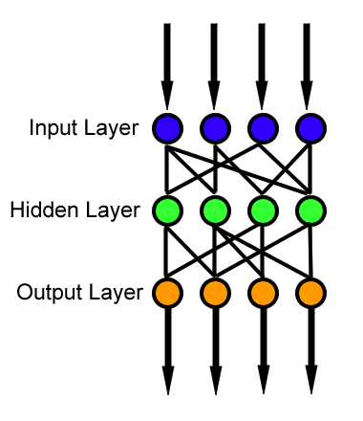Feed Forward

1. **Compare and contrast feed forward networks with recurrent networks**

Feed forward

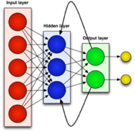Recurrent – best for sequential.

Recurrent networks used for:

* Stock selection
* Sequence
* Text generation
* Voice recognition
  + 1. **A simple network to classify handwritten digits**

1. **Argue for a natural order for solving the two problems of segmenting digits and classifying digits**

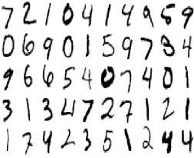

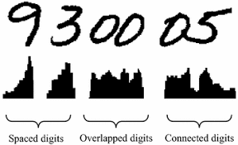

First you have to divide a number into its basic digits.



1. **Calculate the required input neurons for classifying an individual digit in an image of a certain size of pixels**

Training data for the network will consist of many 28x28 pixel images of scanned handwritten digits, and so the input layer contains 784=28×28 neurons.

There is no rule of thumb to find out how many hidden layers you need.

1. **Explain the choice to use 10 output neurons instead of four for classifying an individual digit**

It makes for a better heuristic. 0-9 digits can be outputted.

* + 1. **Learning with gradient descent**

1. **Recognize a quadratic cost function of weights and biases and alternative terminology for the cost function.**

A Cost or Loss or Objective function is a measure of how wrong the model is in terms of its ability to estimate the relationship between X and Y.

The quadratic cost function is sometimes referred to as the mean squared error or MSE.



Note: Fire is the Cost Function when kids learn.

We want to find the set of weights and biases that make the cost function as small as possible. We do this with an algorithm called “gradient descent.”

1. **Explain why minimizing a quadratic cost function is preferable to different types of cost functions**

The quadratic cost function is preferable to other cost functions because it is smooth.

This makes it easier to figure out how to make small changes in the weights and biases so as to get an improvement in the cost.

1. **Recognize an equation for an update rule the defines the gradient descent algorithm and explain the purpose of each component**

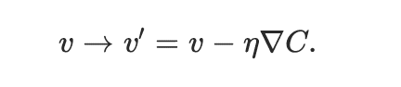

η is our learning rate.

*C* is the gradient vector.

Gradient descent is an optimization algorithm used to MINIMIZE some function by iteratively moving in the direction of steepest descent as defined by the negative of the gradient.

In machine learning, we use gradient descent to update the [parameters](https://ml-cheatsheet.readthedocs.io/en/latest/glossary.html#glossary-parameters) of our model. Parameters refer to coefficients in [Linear Regression](https://ml-cheatsheet.readthedocs.io/en/latest/linear_regression.html) and [weights](https://ml-cheatsheet.readthedocs.io/en/latest/nn_concepts.html#nn-weights) in neural networks.

A low learning rate is more precise, but calculating the gradient is time-consuming, so it will take us a very long time to get to the bottom.

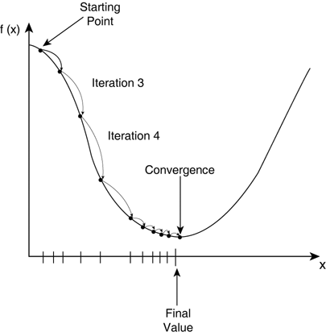

The size of these steps is called the learning rate. With a high learning rate, we can cover more ground each step, but we risk overshooting the lowest point since the slope of the hill is constantly changing.

Gradient Descent is a general function for minimizing a function, in this case the Mean Squared Error (MSE) cost function.

1. **Explain how quickly stochastic gradient descent can speed up learning given a training set size n and a mini-batch size, m.**

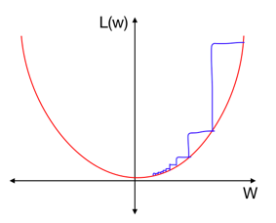 

Note: Mini batches

Stochastic Gradient Descent:

1. Mini -Batch Gradient Descent: Here, instead of iterating over all training examples and with each iteration only performing computations on a single training example, we process **n**training examples at once Just use multiple batches of training data. This is a good choice for very large data sets.

With every GD iteration, you need to shuffle the training set and pick a random training example from that.

Since, you’re only using one training example, your path to the local minima will be very noisy like a drunk man after having one too many drinks.

* + 1. **Implementing a network to classify digits**
  1. **Understand the role of Hyperparameters and their impact output for each Epoch**

Model Hyperparametersare the properties that govern the ENTIRE training process. They are defined before training a model. Weights are internal parameters while hyperparameter examples are the following:

Examples include:

* Learning Rate
* Number of EPOCHS
* Hidden Layers
* Hidden Units
* Activations Functions

One epoch is when an entire dataset is passed both forward and backward through the neural network only once. For example: If we divide a dataset of 2000 training examples into 500 batches, then 4 iterations will complete 1 epoch.

* + 1. **Why deep learning matters**
  1. **Describe deep learning networks in terms of neural networks and their performance relative to networks that are not based on deep learning methods**

Advantage: The biggest advantage of Deep Learning algorithms is that they try to learn high-level features from data in an ***incremental manner***. This eliminates the need of domain expertise and hard-core feature extraction.

